* **[How to create a view](https://sharepoint.rackspace.com/Learning/Articles/Pages/SharePoint-2013--how-to-create-a-view.aspx)**

Why would I want to create a view, you may be asking yourself? Views allow you to better organize your content so it’s easier to find. A list or library without a view is would function but it will take more digging and searching to find the desired content, which will then result in more time and frustration for end-users.  If you create views to simplify the way your content is organized and presented it will promote usability and result in better user adoption.    
  
1. From your SharePoint site open any list or library you would like, in this example I will open my “**Documents**” library.  
  
2. At the top of the page click **LIBRARY** to expand the ribbon.

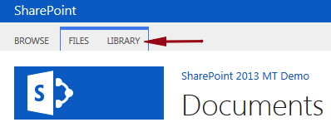

3. In the Settings section click **Library Settings**. (Alternatively I could have clicked Create View in the Manage Views section but I generally like to go to Library Settings because I have the ability to modify/review additional settings.)

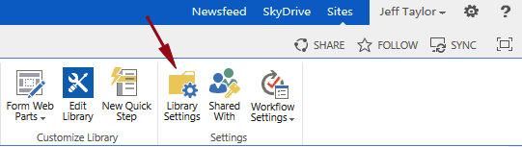

4. On the Document Settings page scroll down and under Views click **Create view**.

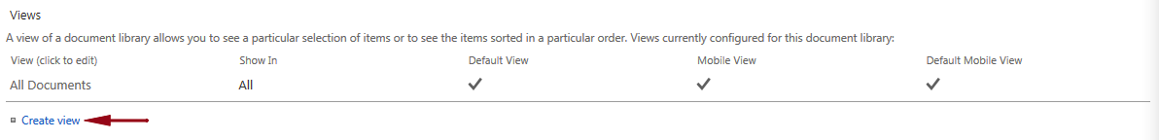

5. On the View Type page choose the view type you would like, in this example I will choose **Standard View**.

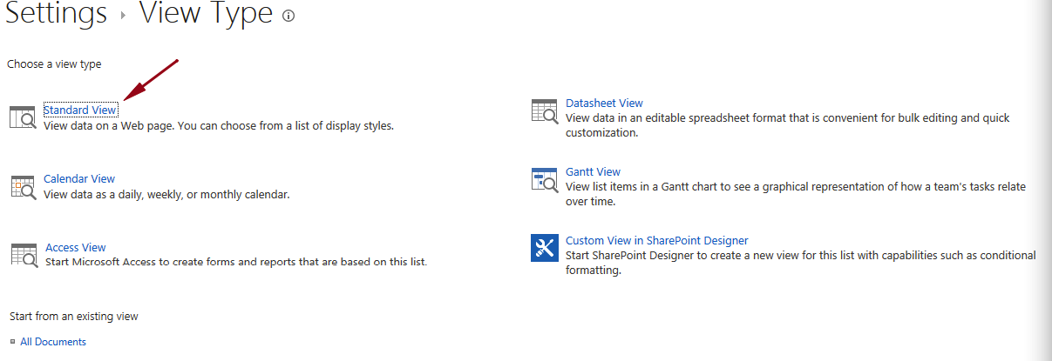

6. Enter the following information below:  
      a. View Name: **Reviewed**

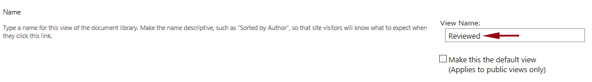

      b. Columns:

* + 1. **Name (linked to document with edit menu)**
    2. **Modified By**
    3. **Reviewed**

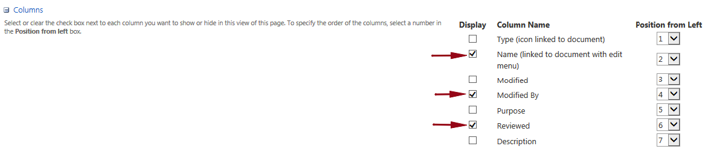

       c. Filter: Show items only when the following is true:

* + 1. **Reviewed**
    2. **is equal to**
    3. **Yes**  
       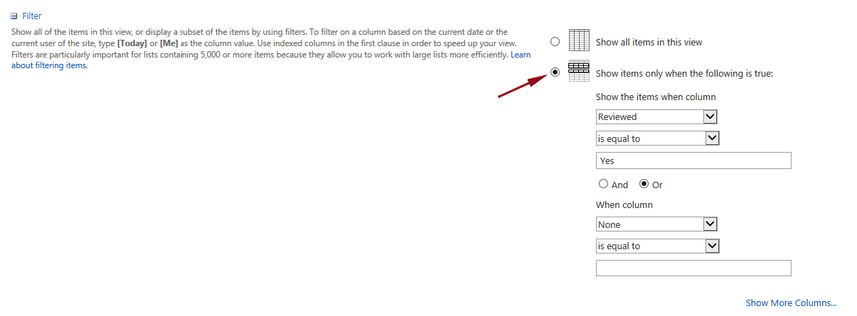  
       Make a mental note of all the different settings you can modify.  In a later tutorial I will go over these additional settings.

7. Review your settings and click **OK**.

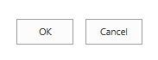

8. You will be taken back to your list or library and the new view, in this example Reviewed will be displayed. 

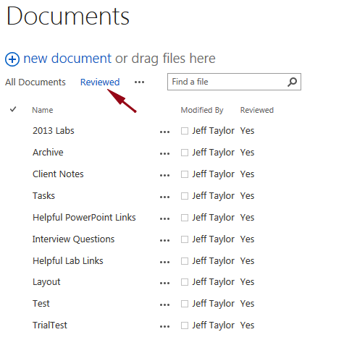

It’s important to note this view was not set as default so once you navigate away from the page and then back again, the All Documents view will be applied. In a later tutorial I will demonstrate modifying additional settings and changing the default view.